**A Tutorial on the R Shiny App for Designing Developmental Toxicology Experiments**

<https://elviscuihan.shinyapps.io/Dc_optimal_design/>

In this write-up, we give a tour on the R Shiny app so that users can get a better flavor of what it does and how it works.

The app is divided into two main panels, the theoretical background panel (orange) and the implementation panel (blue).



**Two main panels**

The theoretical background panel consists of three parts, a recap of abstract of the paper, objective function of the dual optimal design and a brief introduction to the PSO algorithm. We first remind users of the purpose of the paper, i.e., it proposes a departure from the traditional experimental design to determine a dose-response relationship in a developmental toxicology study. Next, as a complement to the original paper, we emphasis that the objective function associated with the design is a convex combination of D-optimality and c-optimality. Different weights and user-specified percentage of lethal dose result in different optimal designs (see implementation panel for more details).

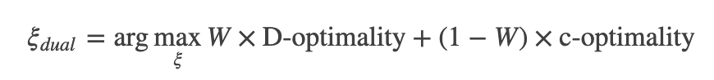

**Dual optimal design**

After that, we briefly introduce the PSO algorithm, which is the backbone of the algorithm to optimize the dual objective function. For those who are interested in details, we refer to the paper Hyun et al (2015).

The implementation panel consists of two sub-panels: the parameter input panel and the result panel. The parameter input panels contains the following user-specified parameters:

|  |  |  |  |
| --- | --- | --- | --- |
| **Parameter**  **Name** | Lower Bound | Upper Bound | LDp |
| **Abbreviation** | LB | UB | LDp |
| **Details** | Predetermined lower bound of the dose range. | Predetermined upper bound of the dose range. | User specified p% of lethal dose. |
| **Parameter Name** | Weight | Grid | r |
| **Abbreviation** | W | grid | r |
| **Details** | weight to control the relative importance between two objectives: 1. estimating the model parameters; and 2. estimating the lethal dose LCp. | The grid density to discretize the predetermined dose interval. Usually grid=1 is sufficient for plotting. | The number of iterations to select the initial design to search the optimal design. Usually r=1 is sufficient but r=0 also generates the optimal design. |
| **Parameter Name** | Nominal values |  |  |
| **Abbreviation** | T |  |  |
| **Details** | 6 sets of nominal values chosen by the user. Note that the number 6 is fixed. We take the arithmetic average of all 6 sets of parameters when calculating the dual objective function. We are working on an improved version allowing user to specify number of sets of parameters and the weights for each set of parameters. | |  |

**The parameter input panel**

When parameters are all set, click the “Search” button to run the algorithm.



**Search button**

On the right, the result panel shows the optimal design and sensitivity function plot. The red dots indicate the doses of the generated design by an algorithm and the plot in blue is called the sensitivity plot of the generated design. If the plot is bounded above by unity throughout the dose interval and has a peak value of one at the dose levels, then the generated design is optimal. Otherwise it is not the best design and so does not have the most optimal value among all designs on the given design interval. Note that different choices of values for Grid and r in the input boxes produce different designs and up to six different sets of possible values for the model parameters may be specified. If there is only one set of nominal values for the model parameters, we input the same values in each of the six rows.

For further questions and comments, please contact elviscuihan@g.ucla.edu.

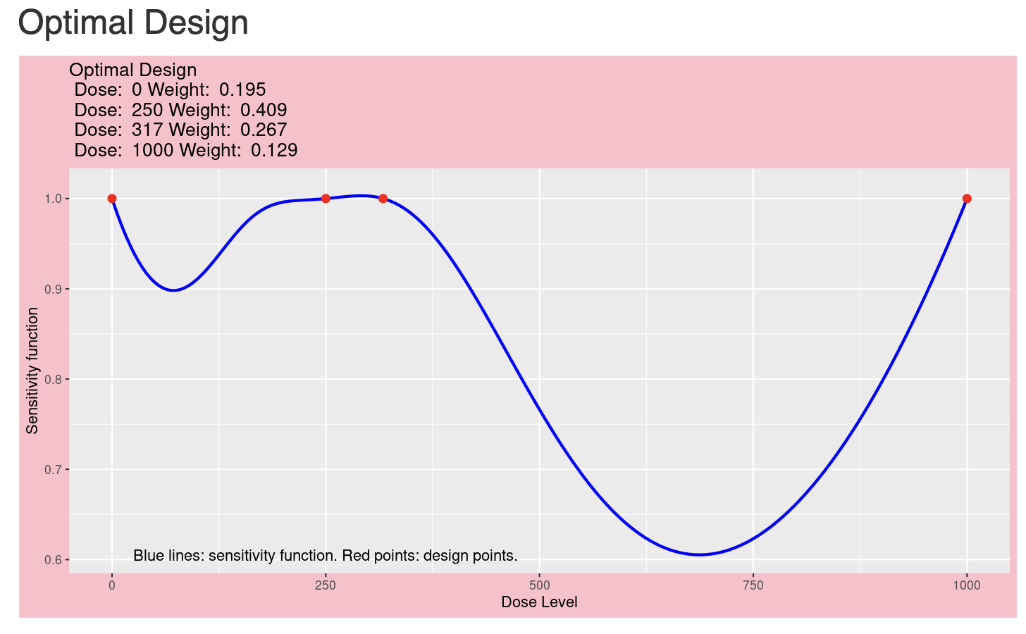

**The result panel**